***TEMA 1 -PLF***

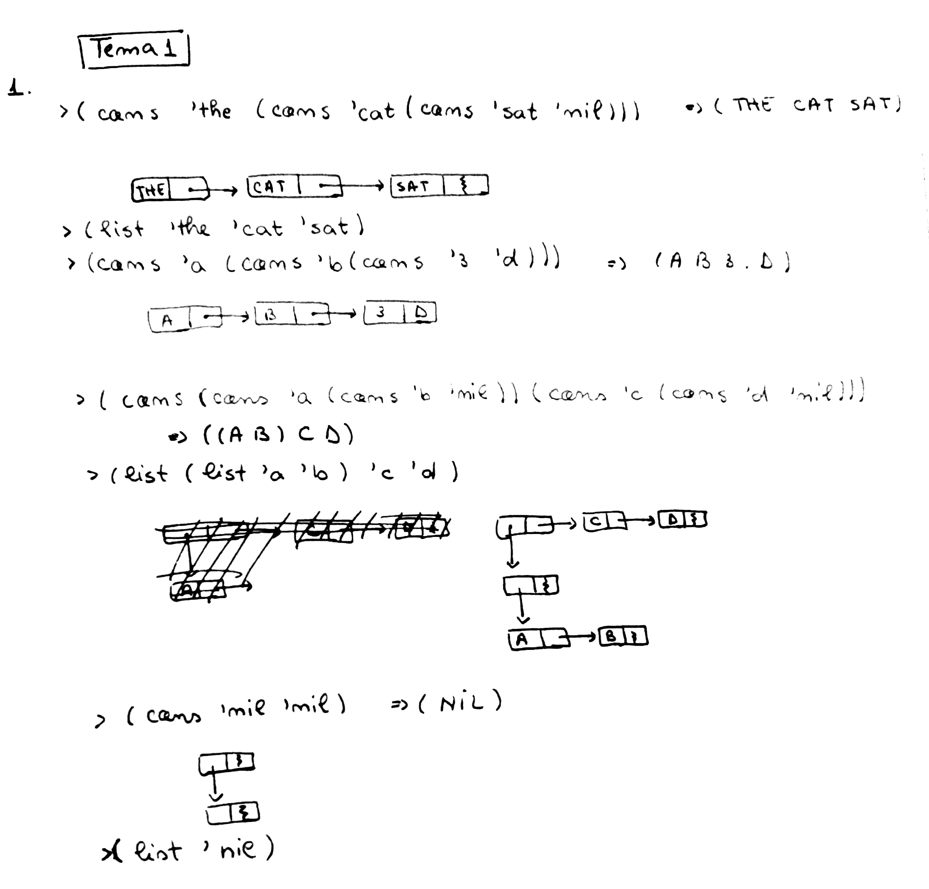

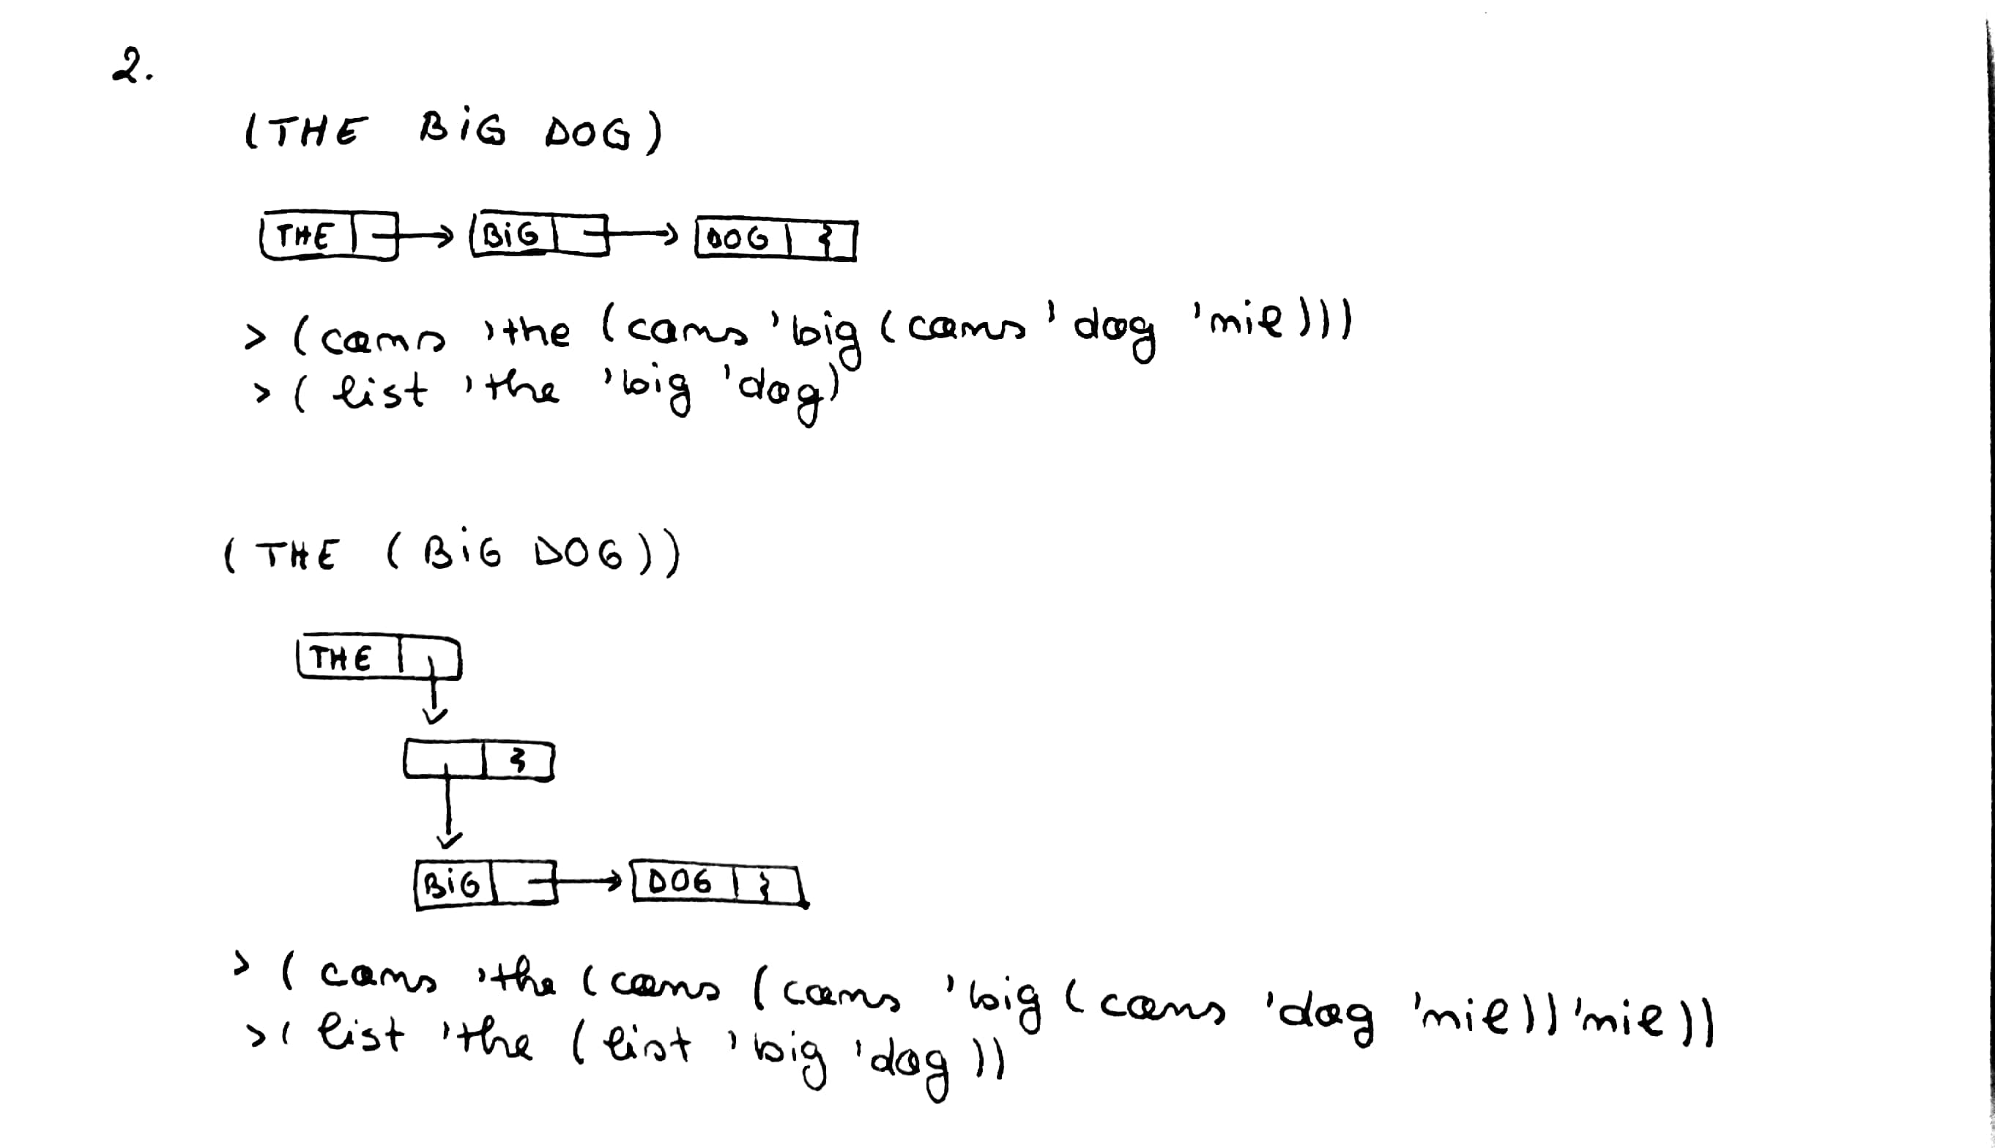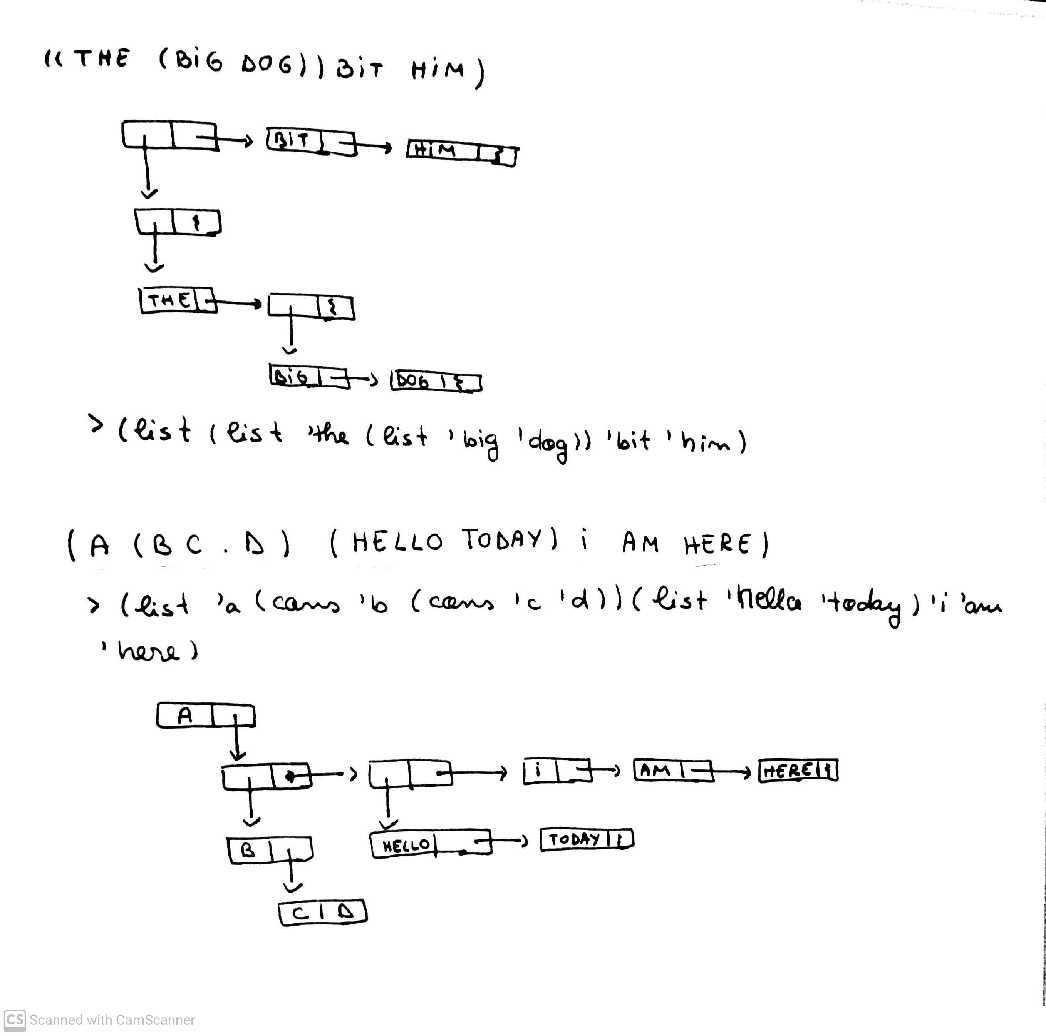

3. Utilizati car, cdr, si combinatii ale lor pentru a returna:

LISTA : (A (L K (P O) ) I ) r e t u r n e a z a : O s i (O) 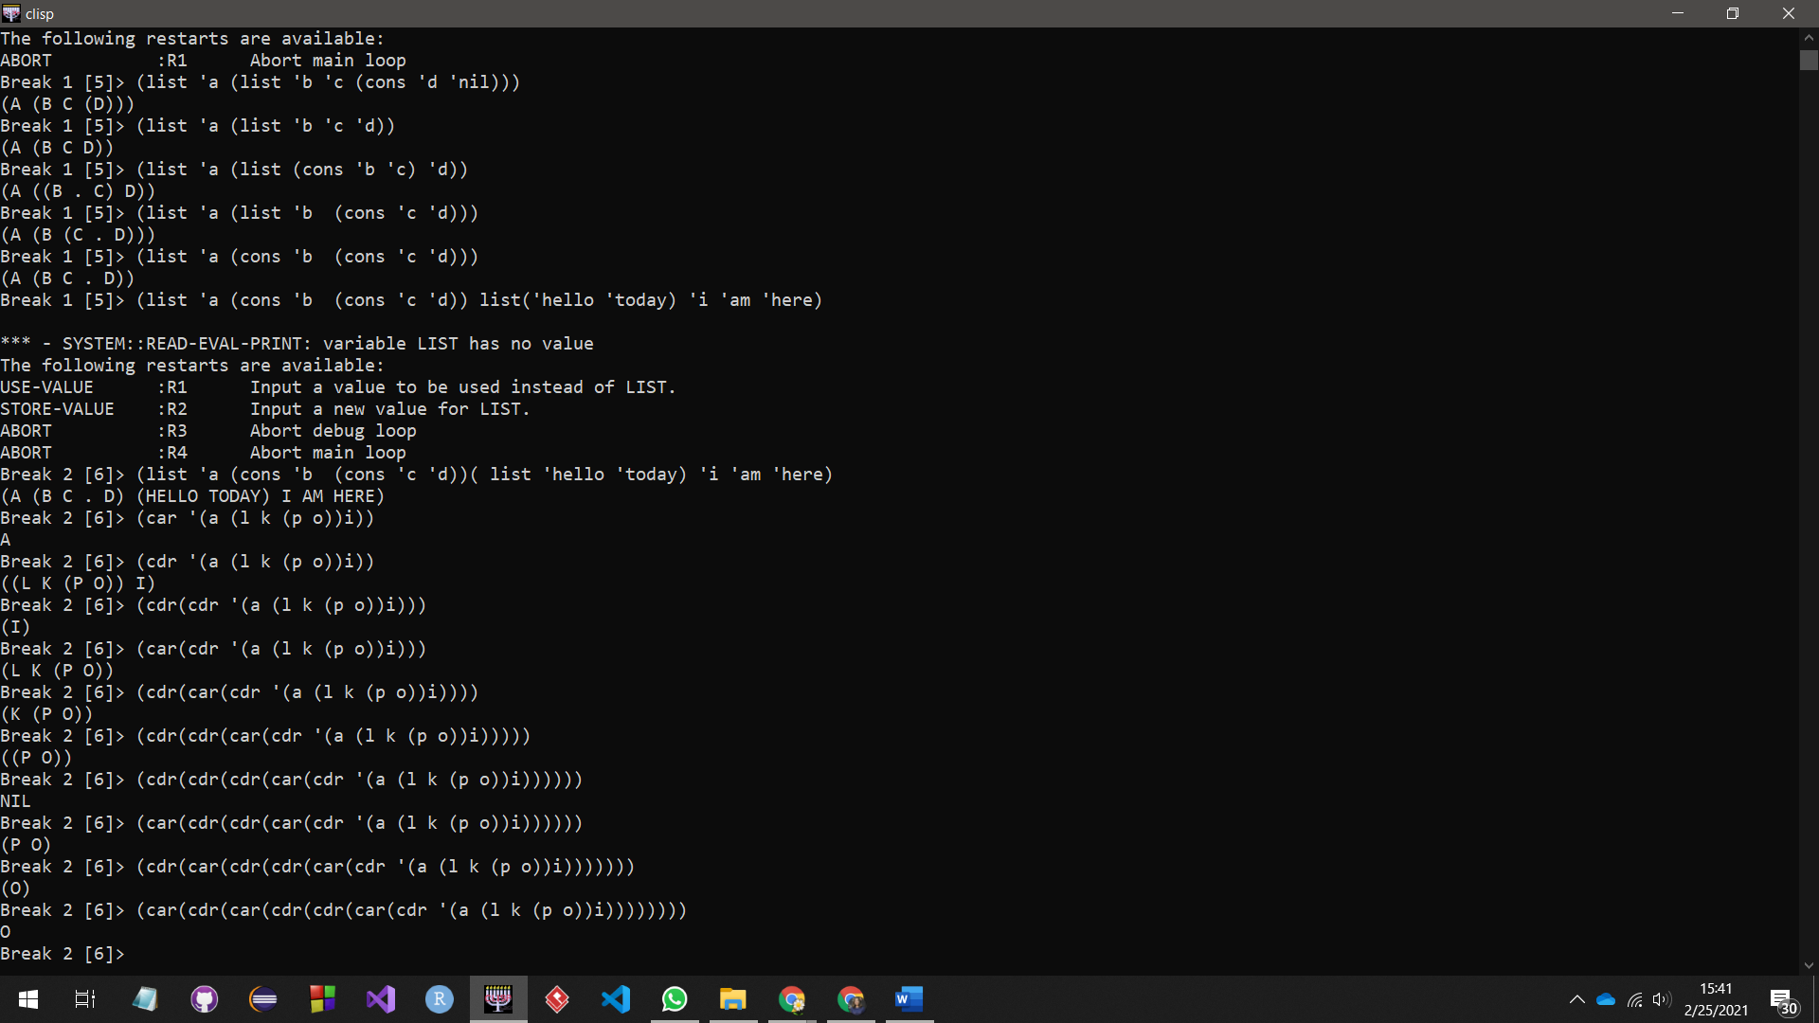**> (cdr(car(cdr(cdr(car(cdr '(a (l k (p o))i)))))))**

**(O)**

**> (car(cdr(car(cdr(cdr(car(cdr '(a (l k (p o))i))))))))**

**O**

LISTA : (A ( ( L K) (P O) ) I ) r e t u r n e a z a : O s i (K)

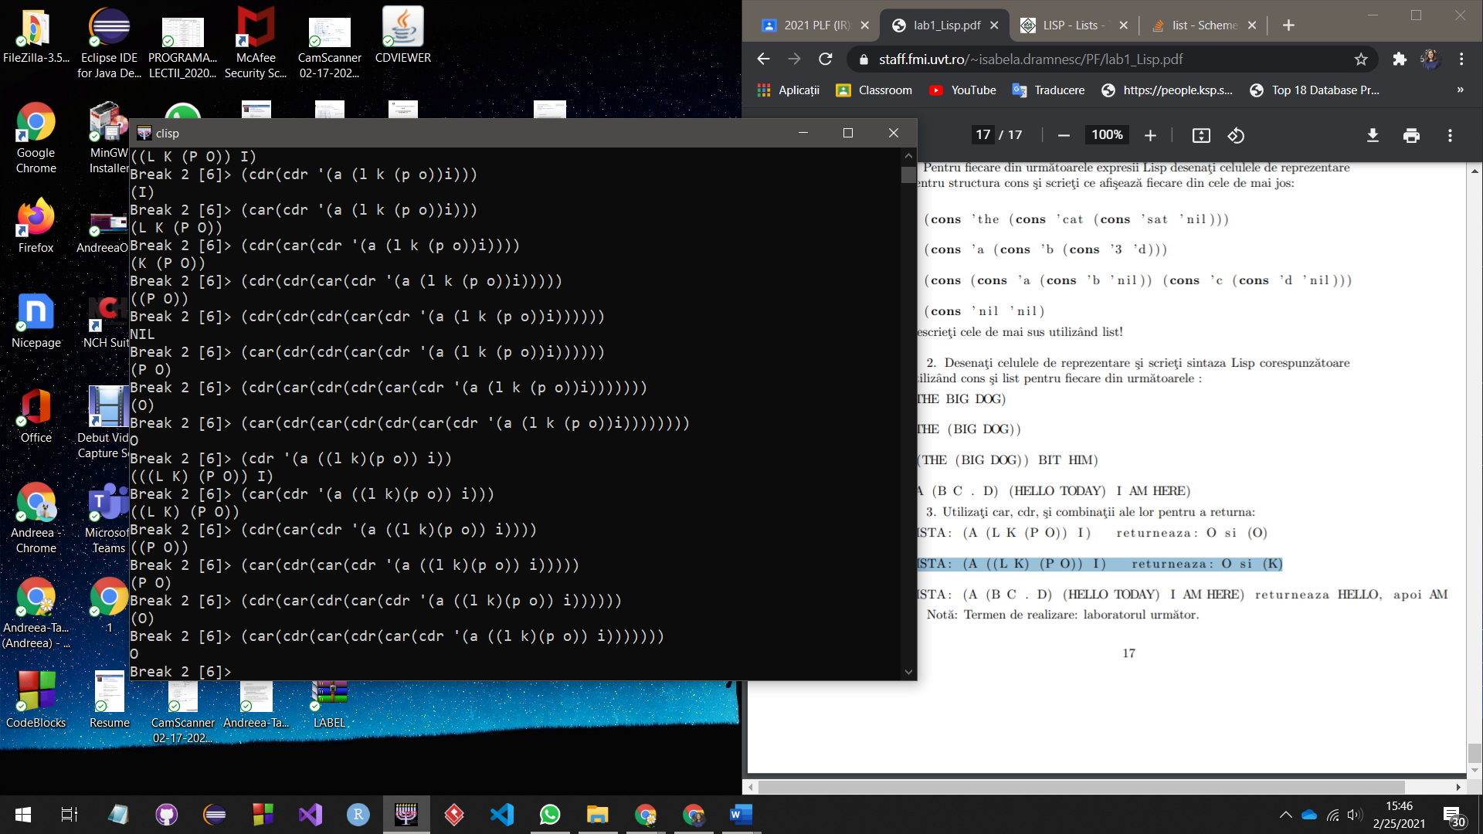

**> (car(cdr(car(cdr(car(cdr '(a ((l k)(p o)) i)))))))**

**O**

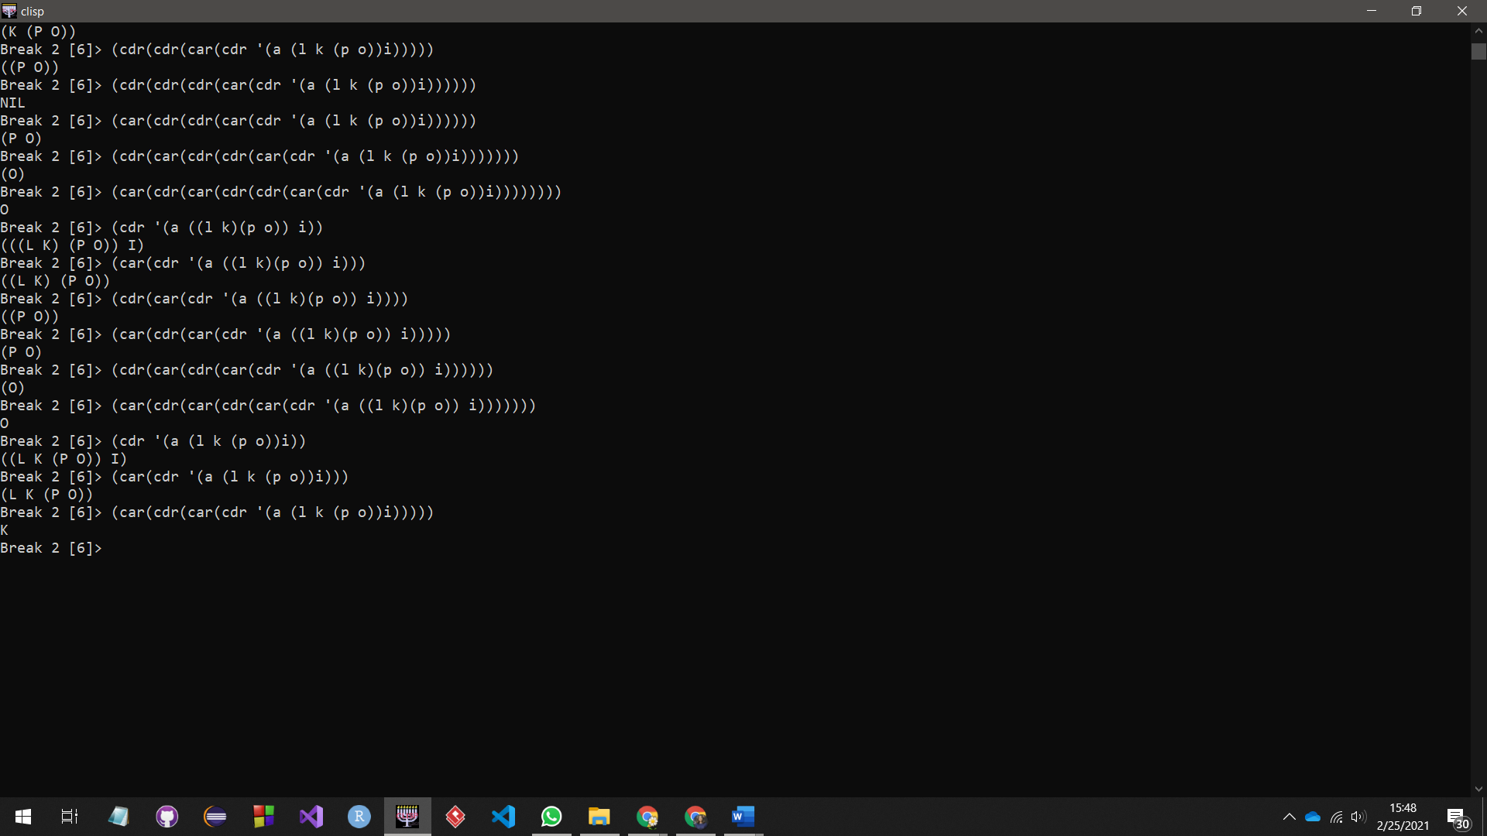

**> (car(cdr(car(cdr '(a (l k (p o))i)))))**

**K**

**> (list(car(cdr(car(cdr '(a (l k (p o))i))))))**

**(K)**

LISTA : (A (B C . D) (HELLO TODAY) I AM HERE) r e t u r n e a z a HELLO, a p oi AM

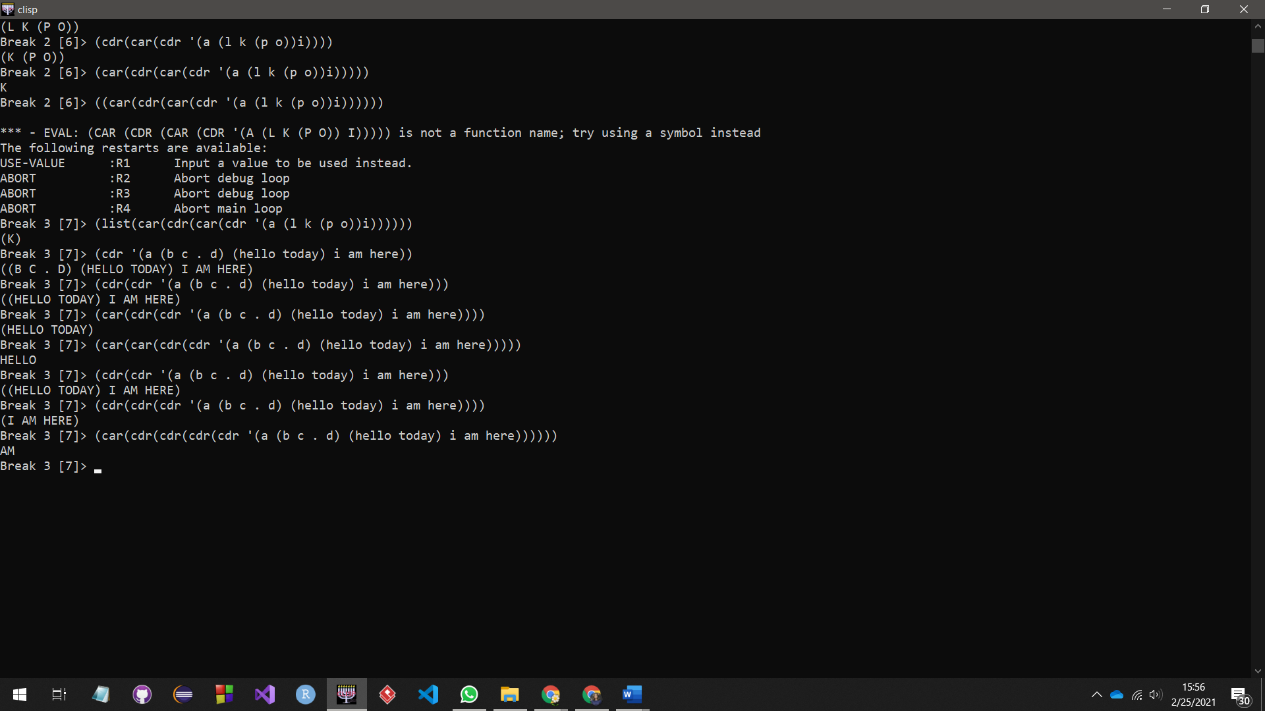

**> (car(cdr(cdr(cdr(cdr '(a (b c . d) (hello today) i am here))))))**

**AM**

**> (car(car(cdr(cdr '(a (b c . d) (hello today) i am here)))))**

**HELLO**